

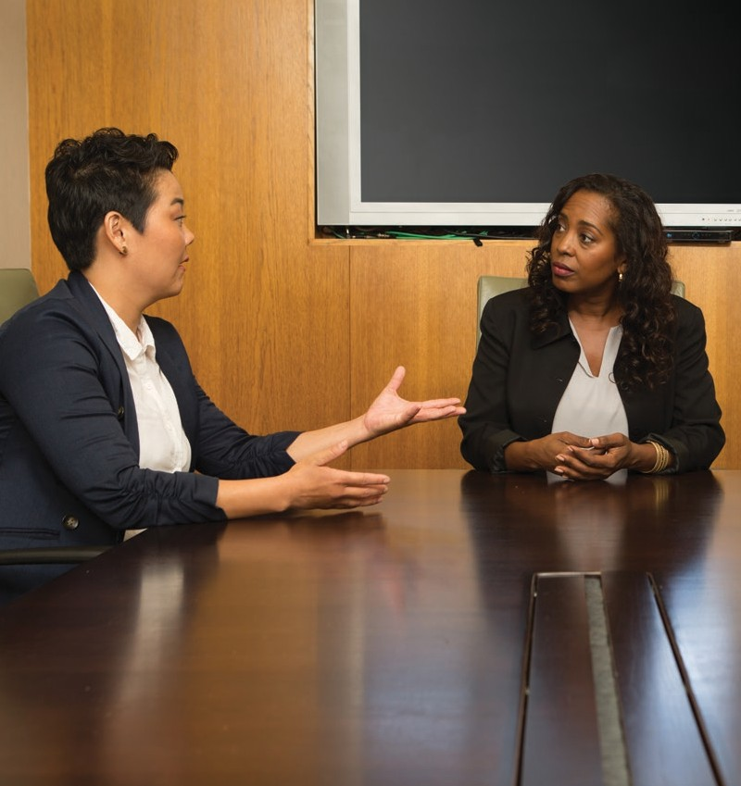UNDERSTANDING YOUR COMMUNICATION STYLE

LEVEL 2 PROJECT



**TABLE OF CONTENTS**

|  |  |
| --- | --- |
| **2** | Introduction |
| **3** | Your Assignment |
| **4** | Assess Your Skills |
| **5** | Competencies |
| **5** | Communication Styles |
| **8** | Effective Use of Communication Styles |
| **9** | Adapting to Other Communication Styles |
| **10** | Review and Apply |
| **11** | Complete Your Assignment |
| **12** | Resources |

**TOASTMASTERS INTERNATIONAL**

[www.toastmasters.org](http://www.toastmasters.org/)

© 2016 Toastmasters International. All rights reserved. Toastmasters International, the Toastmasters International logo, and all other Toastmasters International trademarks and copyrights are the sole property of Toastmasters International and may be used only with permission.

Rev. 11/2016 Item 8206

# INTRODUCTION



Communication is a two-way process for reaching mutual understanding through verbal, non-verbal, and written messages. Communication style is defined

as the way in which individuals interact with one another and the messages they send, intentionally or not, through their behaviors. Determining your own

communication style can help you improve how you share information with others. Learning how to effectively communicate with styles different from your own will enable you to establish effective relationships and create better understanding.

In this project, you will learn how to identify different communication styles, understand your preferred communication style, and recognize how your communication style may impact your interactions with others. You will determine how to improve your relationships by mastering and adapting your communication styles and tailor your message to match situational expectations.

# YOUR ASSIGNMENT

**Purpose:** The purpose of this project is to learn about different communication styles and identify your primary style.

**Overview:** Complete the Discover Your Communication Style questionnaire to help you identify your style. Deliver a 5- to 7-minute speech at a club meeting about your communication style and its impact on your professional and/or personal relationships. If you are uncomfortable discussing your communication style, you may speak about the communication styles you have encountered and how they impact you. Your speech should not be a report of the content of this project.



**For all assignment details and requirements, review the Project Checklist on page 12.**



Throughout this project you will see icons in the margins next to the text. These icons indicate additional resources available online.

**Video:** Sign in to Base Camp to watch a video that supports this project.

**Interactive Activity:** Sign in to Base Camp to complete an interactive activity.

**Resource:** Sign in to Base Camp to view this resource online.

# ASSESS YOUR SKILLS

Evaluate your current skill level by rating each statement.



Select the appropriate number based on your skills today:

**5**

EXEMPLARY

**4**

EXCEL

**3**

ACCOMPLISHED

**2**

EMERGING

**1**

DEVELOPING

|  |  |  |  |  |  |  |  |  |  |  |
| --- | --- | --- | --- | --- | --- | --- | --- | --- | --- | --- |
| Pre-Project | | | |  | Statement | Post-Project | | | | |
|  | | | |  |  |  | | | | |
| **5** | **4** | **3** | **2** | **1** | I understand different communication styles. | **5** | **4** | **3** | **2** | **1** |
| **5** | **4** | **3** | **2** | **1** | I am aware of my preferred communication style. | **5** | **4** | **3** | **2** | **1** |
| **5** | **4** | **3** | **2** | **1** | I understand how my behavior and chosen communication style(s) may impact my interactions with others. | **5** | **4** | **3** | **2** | **1** |
| **5** | **4** | **3** | **2** | **1** | I can select or adjust my communication style to fit any situation or relationship. | **5** | **4** | **3** | **2** | **1** |
| **5** | **4** | **3** | **2** | **1** | I recognize how this project applies to my life outside of Toastmasters. | **5** | **4** | **3** | **2** | **1** |

# COMPETENCIES

#### The following is a list of competencies that you will learn and practice in this project.

* Understand different communication styles.
* Identify your preferred communication style.
* Recognize how your communication style may impact your interactions.
* Determine how to improve your relationships by mastering and adapting your application of communication styles based on the situation.
* Tailor your style to match situational expectations.

# COMMUNICATION STYLES

### DISCOVER YOUR COMMUNICATION STYLE

At this time, complete the following questionnaire. Please choose the word that is **most** descriptive of you.



###### I like to be seen as

* + 1. Sociable
    2. Decisive
    3. Cautious
    4. Patient

###### When collaborating with others, I am

* + 1. Competitive
    2. Spontaneous
    3. Cooperative
    4. Precise

###### When it comes to sharing feelings with others, I am

* + 1. Reserved
    2. Sympathetic
    3. Private
    4. Self-assured

###### Others would describe me as

* + 1. Gentle
    2. Fun-loving
    3. Results-oriented
    4. Disciplined

###### I like my appearance to be

* + 1. Formal
    2. Casual
    3. Stylish
    4. Business-like

###### I want support for my

* + 1. Goals
    2. Ideas
    3. Feelings
    4. Thoughts

###### When working on a project, I am

* + 1. Enthusiastic
    2. Ambitious
    3. Purposeful
    4. Persistent

###### Some may perceive me negatively as

* + 1. Indecisive
    2. A perfectionist
    3. Impulsive
    4. Strong-willed

###### As a leader, I would be perceived as

* + 1. Focused
    2. A risk-taker
    3. Dependable
    4. A problem-solver

###### When placed in a new situation, I am

* + 1. Conscientious
    2. Fearless
    3. Optimistic
    4. Friendly

###### My perfect occupation would give me a sense of

* + 1. Accomplishment
    2. Enjoyment
    3. Acceptance
    4. Accuracy

###### My favorite way to work is by

* + 1. Networking
    2. Brainstorming
    3. Delegating
    4. Working independently

### IDENTIFYING YOUR COMMUNICATION STYLE

At this time, refer to the Communication Style Scoring Guide on page 17 to identify your communication style. Calculate your scores and keep them available for review as you read through the remainder of this project.

Most people will find they produce a score in multiple categories. Each communication style has value and there is no best overall style. Having a higher score in one communication style indicates you are comfortable using that style in many situations, but is not necessarily what you choose in all communication. The goal of understanding your communication style preferences is to communicate with others in a way that is comfortable and effective.

###### Direct

This style is decisive, competitive, independent, and confident. Because the person with a Direct communication style is focused, results-oriented, ambitious, goal-oriented, and driven, others may perceive her as strong-willed or demanding. She can be seen as impatient when bored.

She likes to feel in control and may become frustrated if dependent on others. She measures progress by achievements and successes and is motivated by challenges. At work she displays more concern for results than relationships and does not easily share feelings. Her pace is fast and decisive and she likes a busy, efficient, structured, and formal environment.

###### Initiating

This style is sociable, enthusiastic, energetic, spontaneous, and fun-loving. Due to the gregarious nature of the person with an Initiating communication style, he may be perceived as someone who talks more than listens. He is often perceived as self- assured, innovative, and persuasive.

He likes to feel accepted and is motivated by relationships. He responds strongly to praise and approval. His pace is fast and he may appear impulsive at times. He prefers a stimulating, personal, and friendly work environment.

###### Supportive

This style is calm, steady, approachable, sincere, and gentle. Because the person with a Supportive communication style dislikes change, she may appear indecisive. More often she is perceived as careful, patient, and amiable. Due to her active listening skills, others see her as cooperative, dependable, and loyal.

She is often modest and prefers praise be given privately. Patient and slow-paced, she likes a personal, relaxed, no-tension environment. She puts high priority on close relationships and does not like conflict, but may mediate if necessary.

###### Analytical

This style is precise, exact, analytical, and logical. Because the person with an Analytical communication style is systematic and task-oriented, he is sometimes perceived as a perfectionist. He is organized, self-reliant, purposeful, and diplomatic.

He is motivated by certainty and will rarely give an opinion unless asked. He is slow and cautious in his pace and likes a structured, ordered, and functional environment. Because he needs to feel sure of his position and others’

expectations, he is often private with personal information and does not easily express emotions.

# EFFECTIVE USE OF COMMUNICATION STYLES

It is important to recognize how effective communication can impact your interactions with others. It can lead to higher efficiency and good morale in the workplace, increased innovation and creative potential in groups, and satisfactory personal and familial relationships.

Communication styles are often situational. Be sure to monitor your application of communication styles. Decide if your current style is effective based on feedback and outcomes. If necessary, adjust your behavior and adopt new styles to fit a situation, team, or person.

There is much research and many theories about communication styles and their impacts. To develop a deeper understanding, you may choose to do your own research.

# ADAPTING TO OTHER COMMUNICATION STYLES

Direct Communicators

Direct communicators prefer when you get to the point quickly and in a succinct manner. When dealing with these communicators, be specific and avoid over-explaining or repeating yourself. Focus on solutions and only provide details when asked.

Initiating Communicators

Initiating communicators value interacting with others and sharing stories. Allow time for socializing at the beginning of meetings and create a friendly, non-threatening environment. Provide time for them to express their feelings and opinions.

Supportive Communicators

Supportive communicators appreciate a calm, steady approach. Earn their trust by providing them with plenty of reassurance. When seeking their opinions and ideas, encourage them to express their concerns and allow them time to make decisions.

Analytical Communicators

Analytical communicators like facts and figures. Present information to them in an organized manner and be prepared to answer questions. Be patient while they think through and process new information.

**REVIEW AND APPLY**

Before you complete the assignment, take a moment to read through the questions you see here. If you are not able to answer them comfortably, review the project.

* When might you want to adjust your communication style?
* How can an understanding of your communication style improve your interactions with others?
* How does your preferred communication style impact you as a listener?
* How can you tailor your communication style to match situational expectations?



# COMPLETE YOUR ASSIGNMENT



Now that you have read through the project, plan and prepare your speech or report.

**Review:** Return to page 3 to review your assignment.

**Organize:** Use the Project Checklist on page 12 to review the steps and add your own. This will help you organize and prepare your assignment.



**Schedule:** Work with the vice president education to schedule your speech.

**Prepare:** Prepare for your evaluation. Review the evaluation resources on pages 14–16 and share all resources with your evaluator before your speech. You may choose to share your evaluation resources online.



**Purpose:** The purpose of this project is to learn about different communication styles and identify your primary style.

PROJECT CHECKLIST

Understanding Your Communication Style

**Overview:** Complete the Discover Your Communication Style questionnaire to help you identify your style. Deliver a 5- to 7-minute speech at a club meeting about your communication style and its impact on your professional and/or personal relationships. If you are uncomfortable discussing your communication style, you may speak about the communication styles you have encountered and how they impact you. Your speech should not be a report of the content of this project.

This project includes:

* The Discover Your Communication Style questionnaire
* A 5- to 7-minute speech

Below are tasks you will need to complete for this project. Please remember, your project is unique to you. You may alter the following list to incorporate any other tasks necessary for your project.

Complete the Discover Your Communication Style questionnaire.

Schedule your speech with the vice president education.

###### Write your speech. Include information about your current communication style and how you can effectively adapt your communication to connect with other styles. If you are uncomfortable discussing your communication style, you may speak about styles you have encountered and how they impact you.

Rehearse your speech.

PROJECT CHECKLIST – Understanding Your Communication Style

###### After you have completed all components of the assignment, including your speech, return to page 4 to rate your skills in the post-project section.

Additional Notes

Member Name Date

EVALUATION FORM

Understanding Your Communication Style

Evaluator Speech Length: 5 – 7 minutes

Speech Title

Purpose Statements

* The purpose of this project is for the member to learn about different communication styles and identify his or her primary style.
* The purpose of this speech is for the member to share the impact of his or her style on others.

#### Notes for the Evaluator

During the completion of this project, the member responded to a questionnaire to help identify his or her communication style.

About this speech:

* The member will deliver a well-organized speech about some aspect of communication styles.
* The member may choose to speak about his or her own communication style or the impact of communication styles on him or her.
* The speech may be humorous, informational, or any style the member chooses.
* The speech should not be a report on the content of the “Understanding Your Communication Style” project.

#### General Comments

You excelled at:

You may want to work on:

To challenge yourself:

EVALUATION FORM – Understanding Your Communication Style

For the evaluator: In addition to your verbal evaluation, please complete this form.

**5**

EXEMPLARY

**4**

EXCELS

**3 2**

ACCOMPLISHED EMERGING

**1**

DEVELOPING

**Clarity:** Spoken language is clear and is easily understood

**5 4 3 2 1**

**Vocal Variety:** Uses tone, speed, and volume as tools

## 5 4 3 2 1

**Eye Contact:** Effectively uses eye contact to engage audience

## 5 4 3 2 1

**Gestures:** Uses physical gestures effectively

## 5 4 3 2 1

**Audience Awareness:** Demonstrates awareness of audience engagement

and needs

## 5 4 3 2 1

**Comfort Level:** Appears comfortable with the audience

## 5 4 3 2 1

**Interest:** Engages audience with interesting, well-constructed content

## 5 4 3 2 1

**Topic:** Shares some aspect of his or her communication style and the impact of that style on self or others

## 5 4 3 2 1

Comment:

Comment:

Comment:

Comment:

Comment:

Comment:

Comment:

Comment:

This criteria lists the specific goals and expectations for the speech. Please review each level to help you complete the evaluation.

EVALUATION CRITERIA

Understanding Your Communication Style

##### Clarity

**5** – Is an exemplary public speaker who is always understood

**4** – Excels at communicating using the spoken word **3** – Spoken language is clear and is easily understood **2** – Spoken language is somewhat unclear or

challenging to understand

**1** – Spoken language is unclear or not easily understood

##### Vocal Variety

**5** – Uses the tools of tone, speed, and volume to perfection

**4** – Excels at using tone, speed, and volume as tools

**3** – Uses tone, speed, and volume as tools

**2** – Use of tone, speed, and volume requires further practice

**1** – Ineffective use of tone, speed, and volume

##### Eye Contact

**5** – Uses eye contact to convey emotion and elicit response

**4** – Uses eye contact to gauge audience reaction and response

**3** – Effectively uses eye contact to engage audience **2** – Eye contact with audience needs improvement **1** – Makes little or no eye contact with audience

##### Gestures

**5** – Fully integrates physical gestures with content to deliver an exemplary speech

**4** – Uses physical gestures as a tool to enhance speech

**3** – Uses physical gestures effectively

**2** – Uses somewhat distracting or limited gestures

**1** – Uses very distracting gestures or no gestures

##### Audience Awareness

**5** – Engages audience completely and anticipates audience needs

**4** – Is fully aware of audience engagement/needs and responds effectively

**3** – Demonstrates awareness of audience engagement and needs

**2** – Audience engagement or awareness of audience requires further practice

**1** – Makes little or no attempt to engage audience or meet audience needs

##### Comfort Level

**5** – Appears completely self-assured with the audience

**4** – Appears fully at ease with the audience

**3** – Appears comfortable with the audience

**2** – Appears uncomfortable with the audience

**1** – Appears highly uncomfortable with the audience

##### Interest

**5** – Fully engages audience with exemplary, well- constructed content

**4** – Engages audience with highly compelling, well- constructed content

**3** – Engages audience with interesting, well- constructed content

**2** – Content is interesting but not well-constructed or is well-constructed but not interesting

**1** – Content is neither interesting nor well-constructed

##### Topic

**5** – Delivers an exemplary speech about his or her communication style and the impact of that style on self or others

**4** – Delivers an excellent speech about his or her communication style and the impact of that style on self or others

**3** – Shares some aspect of his or her communication style and the impact of that style on self or others

**2** – Mentions some aspect of his or her communication style and the impact of that style on self or others, but does not fully address

**1** – Delivers a speech on a topic other than some aspect of communication styles

a.

Use this scoring sheet to determine your communication style.

COMMUNICATION STYLE SCORING GUIDE

1. Using your completed questionnaire, circle the corresponding letters in the twelve sections below. For example, if you chose *a* for item 1 on the questionnaire, circle *a* in the item 1 section below.
2. Count the number of times you selected each communication style and note the totals in the Results box below.
3. The style with the highest value in the Results box indicates your preferred communication style.

There is no right or wrong communication style, and each has value. A higher score in one communication style indicates you are comfortable using that style in many situations. If you score equally in two or more categories, you are likely to feel comfortable adapting your communication style. Read descriptions of each style on the following page.

|  |  |  |  |  |  |
| --- | --- | --- | --- | --- | --- |
| **1.** | 1. Initiating 2. Direct 3. Analytical 4. Supportive | **5.** | 1. Analytical 2. Supportive 3. Initiating 4. Direct | **9.** | 1. Direct 2. Initiating 3. Supportive 4. Analytical |

|  |  |  |  |  |  |
| --- | --- | --- | --- | --- | --- |
| **2.** | 1. Direct 2. Initiating 3. Supportive 4. Analytical | **6.** | 1. Direct 2. Initiating 3. Supportive 4. Analytical | **10.** | 1. Analytical 2. Direct 3. Initiating 4. Supportive |
| **3.** | 1. Direct 2. Supportive 3. Analytical 4. Initiating | **7.** | 1. Initiating 2. Direct 3. Supportive 4. Analytical | **11.** | 1. Direct 2. Initiating 3. Supportive 4. Analytical |
| **4.** | 1. Supportive 2. Initiating 3. Direct 4. Analytical | **8.** | 1. Supportive 2. Analytical 3. Initiating 4. Direct | **12.** | 1. Initiating 2. Supportive 3. Direct 4. Anayltical |

3 Direct 1 Initiating 4 Supportive 4 Analytical

Results



[**www.toastmasters.org**](http://www.toastmasters.org/)